Suffolk passes bills targeting energy drinks
Originally published: March 19, 2013 5:41 PM
Updated: March 19, 2013 9:48 PM
By PAUL LAROCCO paul.larocco@newsday.com
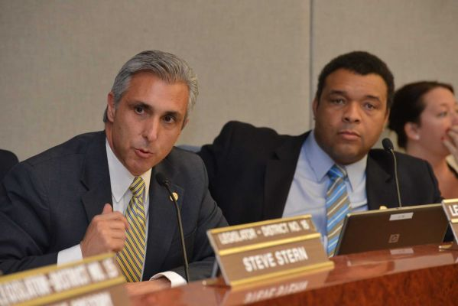
Photo credit: Daniel Brennan | Suffolk County Legislator Lou D'Amaro speaks to other legislators in support of a series of bills that aim to address the health risks associated with energy drinks. (March 19, 2013)
Suffolk lawmakers Tuesday night approved county oversight of energy drinks that supporters touted as the first of its kind in the nation.
The three bills, sponsored by Legis. William Spencer (D-Centerport), passed despite fierce beverage industry resistance.
A ban on the sale of energy drinks at county parks and beaches passed 11-4, with several abstentions; a ban on marketing of the drinks to minors via coupons and free-sample mailings passed 16-0; and a measure that encourages local students to submit videos about the alleged health dangers of the drinks was approved 14-1.
"There's an unlevel playing field with aggressive marketing of the drinks," Spencer said in explaining his reasoning.
Health advocates say energy drinks, which contain additives including guarana and taurine, can cause elevated heart rates, higher blood pressure, dizziness and even death. The beverage industry strongly disagrees, saying the drinks are safe, contain less caffeine than coffee servings of the same size, and that their additives don't enhance the caffeine effects to dangerous levels.
Matthew Vishnick, a lobbyist representing 5-Hour Energy, assailed the ban as "unconstitutional and unjustified," saying the drinks have no banned substances and could be safer than the hot dogs sold at parks.
"If energy drinks were so harmful, we'd have definitive evidence," he said, calling opposing studies inconclusive and hinting that the laws will be challenged by the industry.
Some lawmakers wondered how the county would enforce the ban on samples with counsel acknowledging that officials couldn't really go after companies based outside of Suffolk.
But Legis. Tom Barraga (R-West Islip) said that those focused on potential enforcement issues were missing the point: "These send a message to the general population. That's why they're effective."
The American Beverage Association released a statement after the vote that referenced such comments: "We are disappointed the Suffolk County Legislature has passed misguided legislation that they admit is less about substance and more about sending a message."
Spencer's bills came after a months-long industry lobbying effort to prevent introduction of a much-larger initiative that would have banned the sale of all energy drinks to minors countywide. Legis. Lynne Nowick (R-St. James) had introduced such a measure two years ago, but withdrew it after the industry agreed to label its products as not being recommended for children.
"This is the beginning," Nowick said Tuesday. "There is much more that we can do."
The measures become effective within 60 days of being signed by County Executive Steve Bellone and filed with the state.

